PSEUDO DEVANAGRI
Pseudo-Devanagari is used to understand the foreign languages easily.It is different from the original DEVANAGRI but employs the features of other foreign languages for easy understanding,there are many subscripts included under pseudo-devanagri as a part of constructed fictional languages.
By changing a in different ways, we can the full set of Sanskrit vowels.Now we will learn about all of the ways we can modify this vowel.
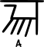 |  | 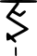 |  | 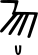
pure consciousness |  | desire |  | knowledge
ri
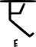 |  | am | aha
 |  | ego | outside environment
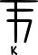 | 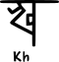 | 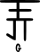 | 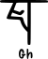 | 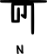
ककार | खकार | गकार | घकार | णकार
 |  |  |  | sky
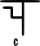 | 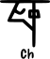 | 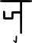 | 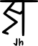
 | taste | form | touch | smell
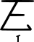 | 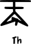 | 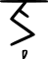 | 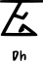
genitals | anus | legs
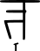 | 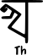 | 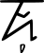 | 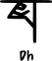 | 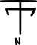
 |  |  | skin
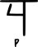 | 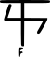 | 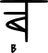 |  | 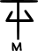
 | ego | knowledge | nature
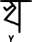 | 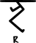 | 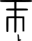 | 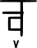
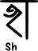 | 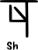 | 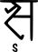
 | 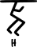
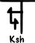 | 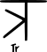 | 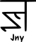
 | 

