UROLOGY PICTOGRAMS
UROLOGIC
dysuria (R30.0)
hematospermia
hematuria (R31)
impotence (N48.4)
polyuria (R35)
retrograde ejaculation
strangury
urethral discharge
urinary frequency (R35)
urinary incontinence (R32)
urinary retention

ANATOMY
 | 
 | 
 | 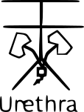
URINARY BLADDER | 

