FEMORAL TRIANGLE
FEMORAL TRIANGLE
- boundaries
  - apex
    - formed by a point where medial and lateral boundaries meet
  - roof
    - skin
    - superficial fascia
      - Superficial inguinal lymph nodes
      - femoral branch of genitofemoral
      - branches of ilioinguinal
      - superficial branches of femoral artery
    - fascia
      - including cribriform fascia covering sapnenous opening
  - floor
  - laterally
    - medial border of sartorius
  - medially
    - medial border of adductor longus
  - base
    - inguinal ligament
- contents
  - nerves
    - femoral
      - The femoral lies lateral to the femoral artery, outside the femoral sheath, in the groove between the iliacus and the psoas major muscles. It is described later.
    - to pectineus
      - The to the pectineus arises from the femoral just above the inguinal ligament. It passes behind femoral sheath to reach the anterior surface of pectineus
    - femoral branch of genitofemoral
      - The femoral branch of the genitofemoral occupies the lateral compa rtment of the femoral sheath along with the femoral artery. It pplies most of the skin over the femoral triangle
    - lateral cutaneous of
      - The lateral cutaneous of the crosses the lateral angle of the triangle. Runs on the teral side of and ends by dividing into anterior and posterior branches. These supply terola teral aspect of front of and lateral aspect of gluteal region respectively
- femoral artery
- femoral sheath
  - The femoral sheath encloses the upper 4 cm of the femoral vessels
  - funnel shaped sleeve of fascia
    - formed by downward extension of 2 layers of abdomen fascia
      - anterior wall by fascia transversalis
      - posterior wall by fascia iliaca
  - lateral wall is vertical
  - medial wall is oblique
  - divided in to 3 compartments
    - lateral or arterial compartment
    - medial or lymphatic compartment
    - intermediate or venous compartment
- femoral vein
  - The femoral vein accompanies the femoral artery. The vein is medial to the artery at base of triangle, but posteromedial to artery at the apex
  - The femoral vein receives the grea t saphenous vein, circumflex veins and veins corresponding to the branches of femoral artery
- femoral canal
  - medial compartment of femoral sheath
    - contains a lymph node called cloquet of rosenmuller
  - The base or upper end of femoral canal is called femoral ring
  - conical in shape
  - boundaries
    - anteriorly by inguinal ligament
    - posteriorly by pectineus
    - medially by lacunar ligament
    - laterally by septum separating from femoral vein
- femoral fossa
  - The parietal peritoneum covering sep tum from above shows a called femoral fossa
- femoral septum
  - The femoral ring is closed by a condensation of
    - extraperitoneal connective tissue called the femoral septum
- inguinal lymph nodes
  - The inguinal lymph nodes lie to the fascia. These lie medial to upper part of femoral vein and receive lymph from superficial inguinal lymph nodes, from glans p enis or clitoris and lymphatics of lower limb

BOUNDARIES
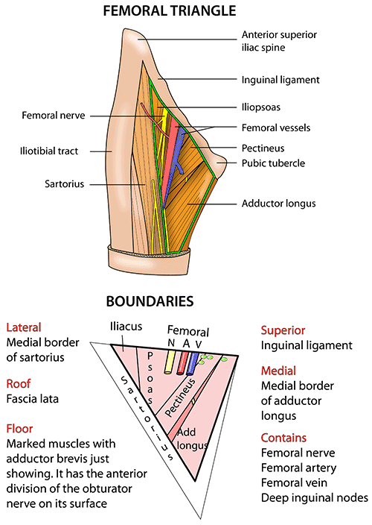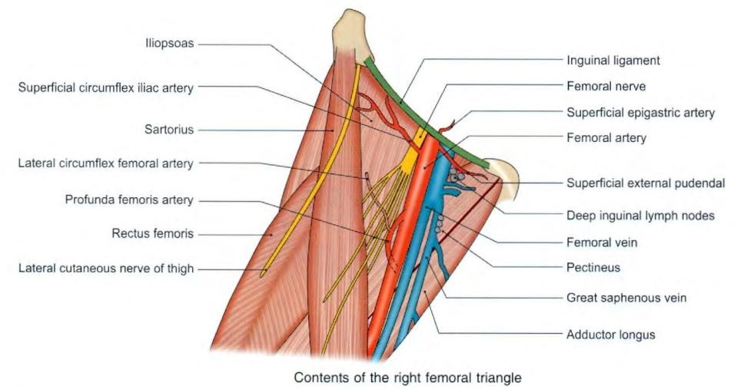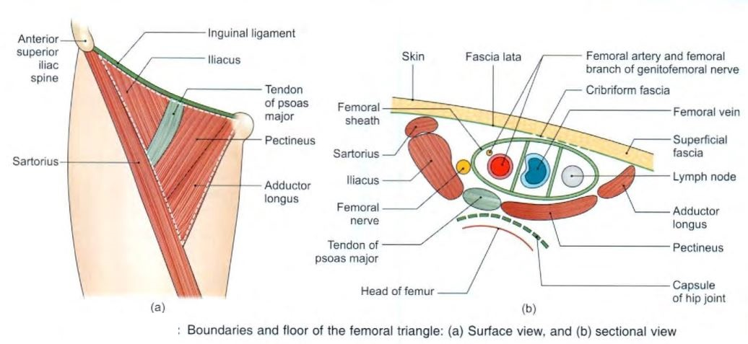

CONTENTS
- Femoral Artery
- Femoral Nerve
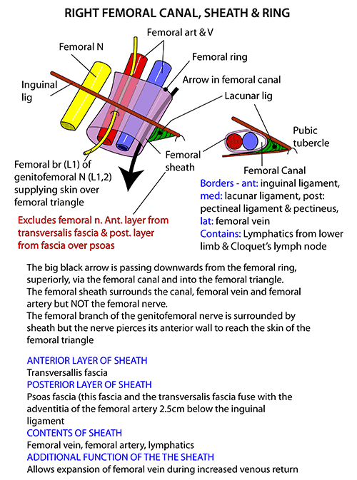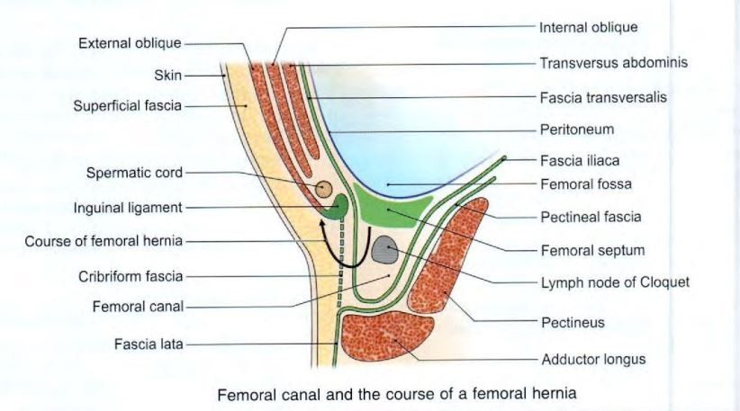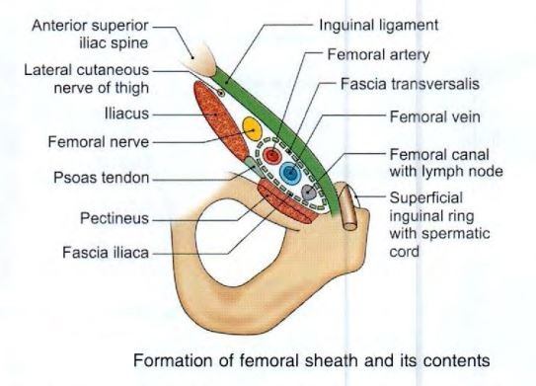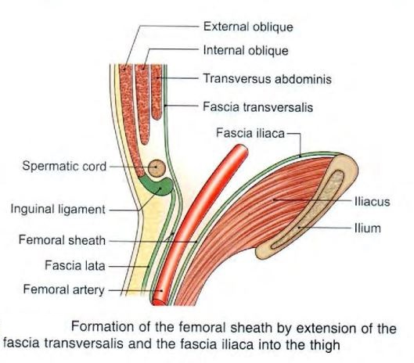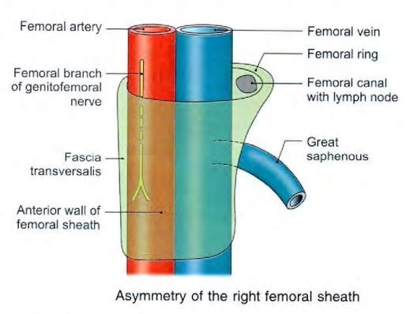

DISSECTION TUTORIALS


