CHARACTER
* Character - brave, coward, courageous , timid, intelligent, stupid, cheat, confident , cruel , kind, honest , doubt , mean
english |  | greek | latin | hindi
Confident |  | aftopepoíthisi | fiducia | आत्मविश्वास
 | 
coward | 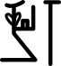 | deilós | ignavus | कायर
brave | 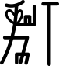 | gennaíos | fortis | बहादुर
courage | 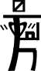 | thárros | animo | साहस
cruel |  | sklirós | crudelis | निर्दयी
kind | 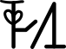 | eídos | benignus | दयालु
mean |  | simaíno | medium | तुच्छ
hope |  | elpída | spes | आशा
wise | 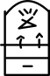
clever | 
intelligent
mental | 
mundane | 
natural | 
talented
stupid
timid | 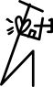
sensitive matter
sensitive
secular
religious
reticent | 
innocent | 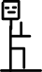
insolent | 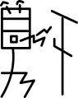
informal | 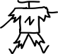
smart | 
unkind | 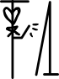
talkative | 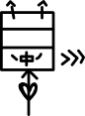
violent | 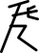
vulgar | 
formal | 

