ANATOMY OF MALE REPRODUCTIVE SYSTEM

SYSTEMA GENITALIA
- Further Information : MALE REPRODUCTIVE SYSTEM
The reproductive organs required for the production of offspring.

Male reproductive system
Main article: reproductive system
- Internal reproductive organs
- Testes
- Epididymis
- Vas deferens
- Seminal vesicles
- Prostate
- Bulbourethral glands
- External reproductive organs
- Penis
- Scrotum

MALE REPRODUCTIVE SYSTEM
- TESTIS
- EPIDIDYMIS
- SPERMATIC CORD
  - External spermatic fascia
  - Cremaster
  - Cremasteric fascia
  - Internal spermatic fascia
  - (Vestige of processus vaginalis)
- DUCTUS DEFERENS; VAS DEFERENS
- SEMINAL GLAND; SEMINAL VESICLE
  - Adventitia
  - Muscular layer; muscular coat
  - Mucosa; mucous membrane
  - Excretory duct
- Ejaculatory duct
- PROSTRATE
- BULBO-URETHRAL GLAND COWPERI
  - Duct of bulbo-urethral
- MALE EXTERNAL GENITALIA
  - PENIS
  - SCROTUM
    - Raphe of scrotum
    - Dartos fascia; superficial fascia of scrotum
      - Septum of scrotum
      - Dartos

EXTERNAL GENITAL ORGANS

PENIS
ROOT OF PENIS
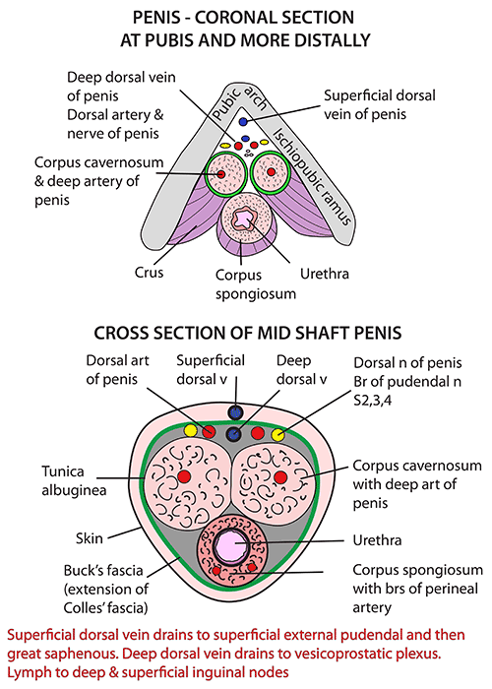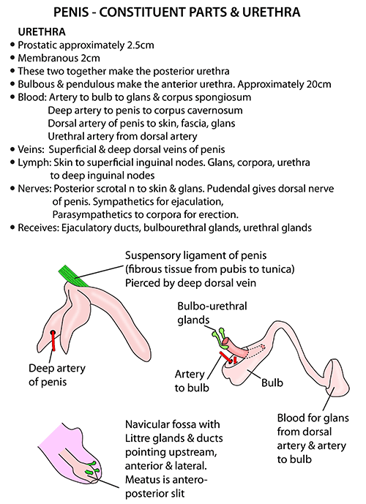
BODY OF PENIS
ARTERIAL SUPPLY
VENOUS DRAINAGE
NERVE SUPPLY

SCROTUM
LAYERS OF SCROTUM
BLOOD SUPPLY
NERVE SUPPLY

TESTIS
SHAPE AND SIZE
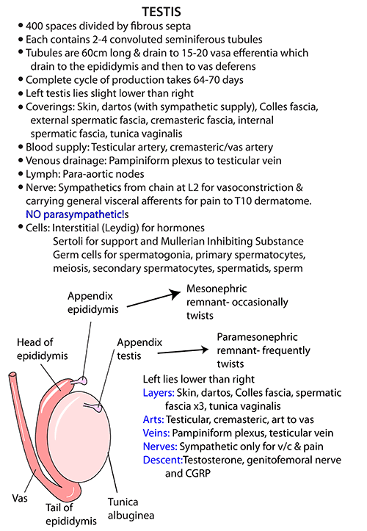
EXTERNAL FEATURES
COVERINGS OF TESTIS
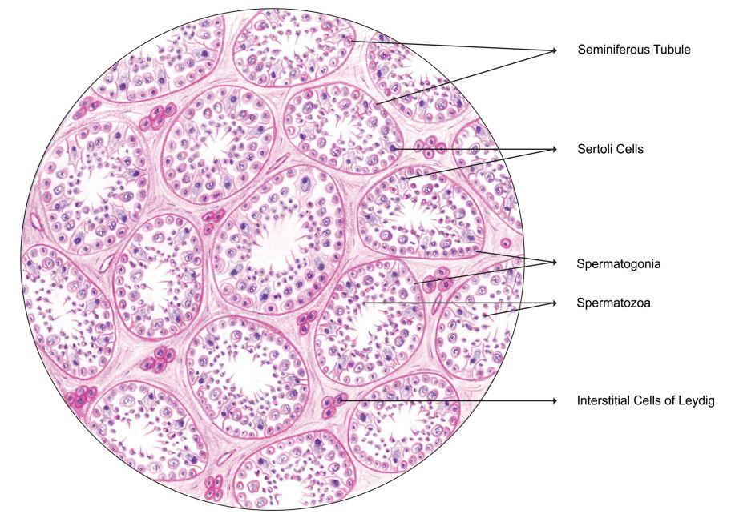
STRUCTURE OF TESTIS
ARTERIAL SUPPLY

EPIDIDYMIS
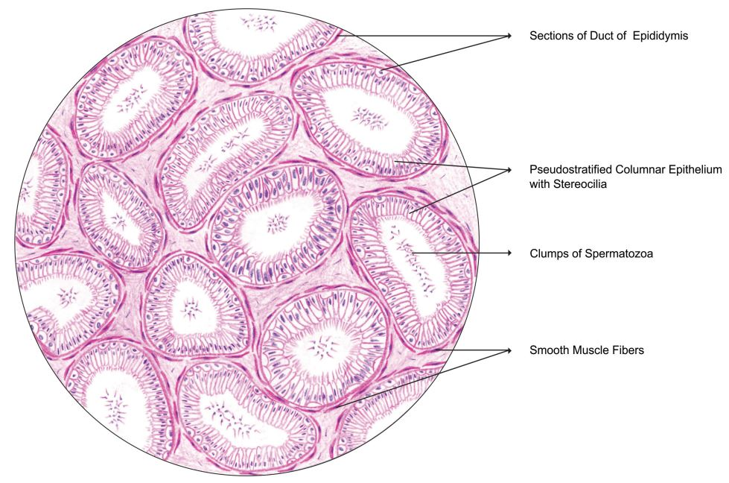

PROSTRATE
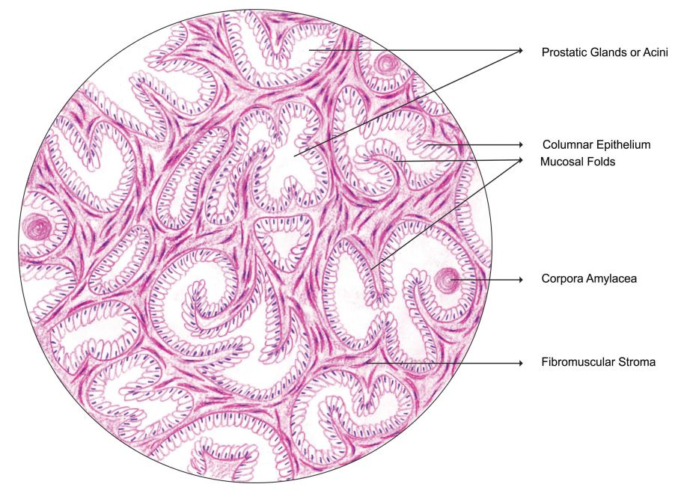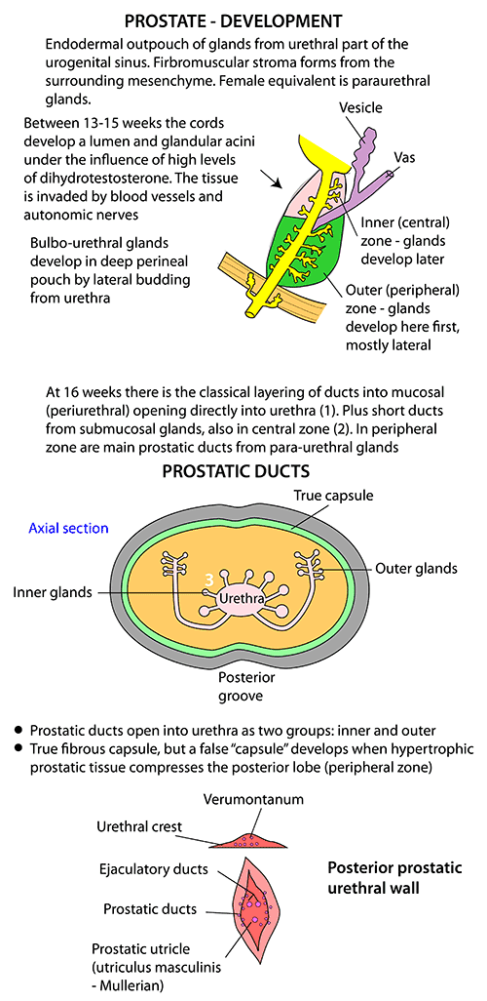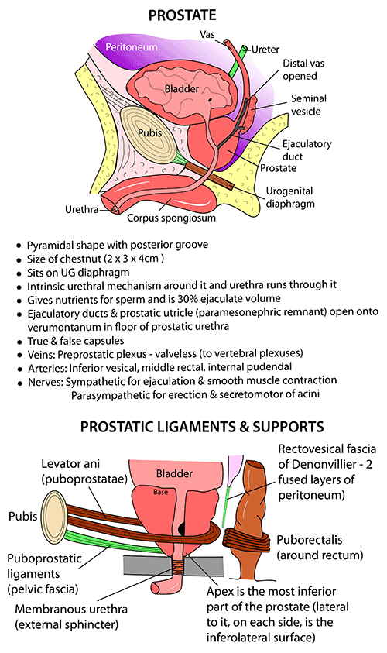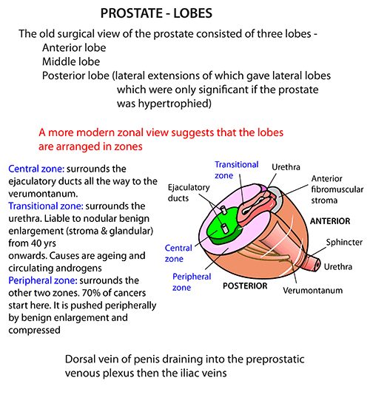

SEMINAL VESICLE


