ADJECTIVE

From Mantropedia
In linguistics, adjective (abbreviated adj) is a word that modifies a or phrase or describes its referent. Its semantic role is to change information given by the .
Traditionally, were considered one of the main parts of speech of the English , although historically they were classed together with .[1] Nowadays, certain words that usually had classified as , including the, this, my, etc., typically are classed separately, as determiners.

ORDER :
- Quantity - of number (e.g. two, ten)
- Opinion – limiter (e.g. a real hero, a perfect idiot) and of subjective measure (e.g. beautiful, interesting) or value (e.g. good, bad, costly)
  - Appearance - ugly , fat , slim , beautiful , ugly , dirty , good , bad, nice , clean , strong , weak , health , disease , sick,alive , dead ,
  - Behaviour - humble, rude, polite, vulgar, punctual , obedient , proudful , shameful
  - - angry , , happy , calm ,
  - Character - brave, coward, courageous , timid, intelligent, stupid, cheat, confident , cruel , kind, honest , doubt , mean
  - others - freedom , captive , correct , incorrect , , dependent , independent , hope ,
  - taste - sweet , sour
- Size – denoting physical size (e.g. tiny, big, extensive)
  - depth - , shallow , superificial ,
  - size - large , small , tiny
- - denoting (e.g. slim, fat, thin , , heavy )
- Age – denoting age (e.g. young, old, new, ancient, six-year-old)
- Temperature - denoting temperature (e.g. cold, warm, hot)
- Humidity - denoting humidity (e.g. dry, wet)
- Shape – describing more detailed physical attributes than overall size (e.g. round, sharp, swollen, blunt, straight, square , hard , soft , smooth , rough , , , empty , full , flat , curved , crooked)
- – denoting (e.g. white, black, pale)
- Pattern - denoting pattern of (e.g. spotted, crackled)
- Origin – denominal denoting source (e.g. French, volcanic, extraterrestrial)
- Material – denominal denoting what something is made of (e.g., woollen, metallic, wooden , new , old , ancient , modern)
- Qualifier/purpose – final limiter, which sometimes forms part of the (compound) (e.g., rocking , hunting cabin, passenger car, )
- active , passive , easy , difficult , enjoy , fear , love , hate , open , close , shine

OPINION
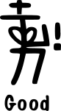 | 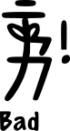 |  | 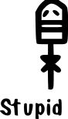
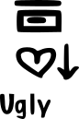 |  |  | 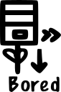
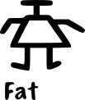 | 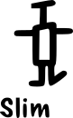 | 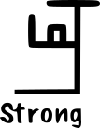 | 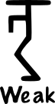
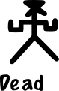 | 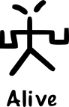 | 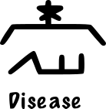 | 


SIZE
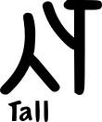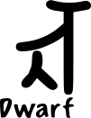

SHAPE
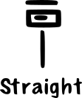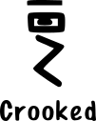

COLOUR


