IDEOGRAM
An or ideograph (from Greek ἰδέα idéa idea and γράφω gráphō to write) is a graphic symbol that represents idea or concept, independent of any particular , and specific words or phrases. Some ideograms are comprehensible only by familiarity with prior convention; others convey their meaning through pictorial resemblance to a physical , and thus may also referred to as pictograms.
The numerals and mathematical symbols are ideograms – 1 'one', 2 'two', + 'plus', = 'equals', and so on (compare the section Mathematics below). In English, the ampersand & is used for 'and' and (as in many languages) for Latin et (as in &c for et cetera), % for 'percent' ('per cent'), # for 'number' (or 'pound', among other meanings), § for 'section', $ for 'dollar', € for 'euro', £ for 'pound', ° for 'degree', @ for 'at', and so on. The reason they are ideograms rather than logograms is that they not denote fixed morphemes: they can read in many different languages, not just English, there is not always only a single way to read them and they are in some cases read as a complex phrase rather than a single word.
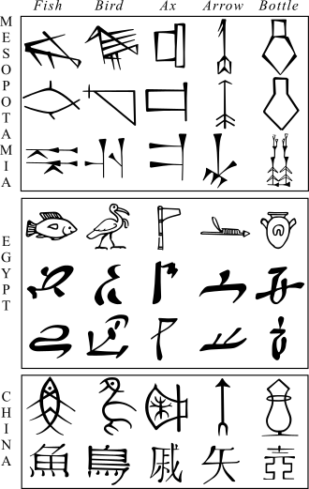
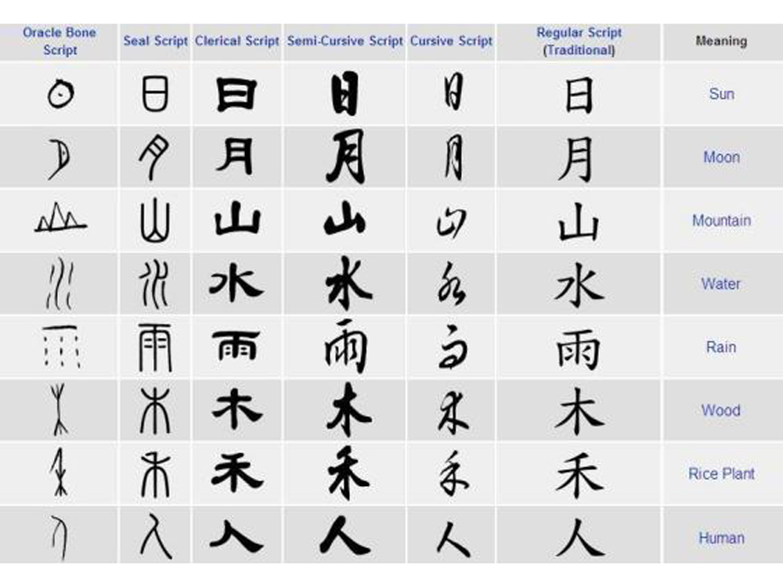
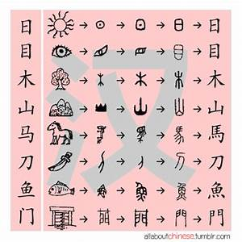

SEE ALSO
- Mathematical Ideograms
- Mantrakshar Ideograms

